Montana Climbing Holds Report

# MIS 321

Prepared by:

Kyle Has

Julie Kangl

Elena Kargopoltsev

Akash Kum

11/6/2020

# Introduction:

Montana Climbing Holds is a proposed startup company that intends to specialize in the manufacturing and sales of climbing equipment. The idea of the company originated from Sasha Montana, an avid rock climber. Montana Climbing Holds will be focused on the manufacturing, sales, and distribution of climbing equipment that is targeted towards climbing enthusiasts. Sasha’s hopes of the business are to create a business model that utilizes her knowledge of information systems and leverage the Software as a Service (SaaS) model to support the functionality of her business.

Through extensive preparation, our team has created a report that will aid Sasha in creating a formal business plan. Our report begins with a Context Data Flow Diagram (DFD), followed by a Level – 0 DFD, and is concluded with an assessment of three ecommerce services that are provided through the SaaS model and our personal recommendation for which software we believe is the best choice.

# DFD Diagrams:

The proposed system will support business processes for sales, inventory management, and reporting. It processes customer orders, starting with the customer’s selection of the products and the revision of their selection. After that, the system can check out the customer and process their payment. It is followed by payment verification and then updating the inventory and sales databases to account for the sale. Through the system, company managers also can update other databases that support the processes. Finally, the system can create reports for managers to help with decision-making in the company.

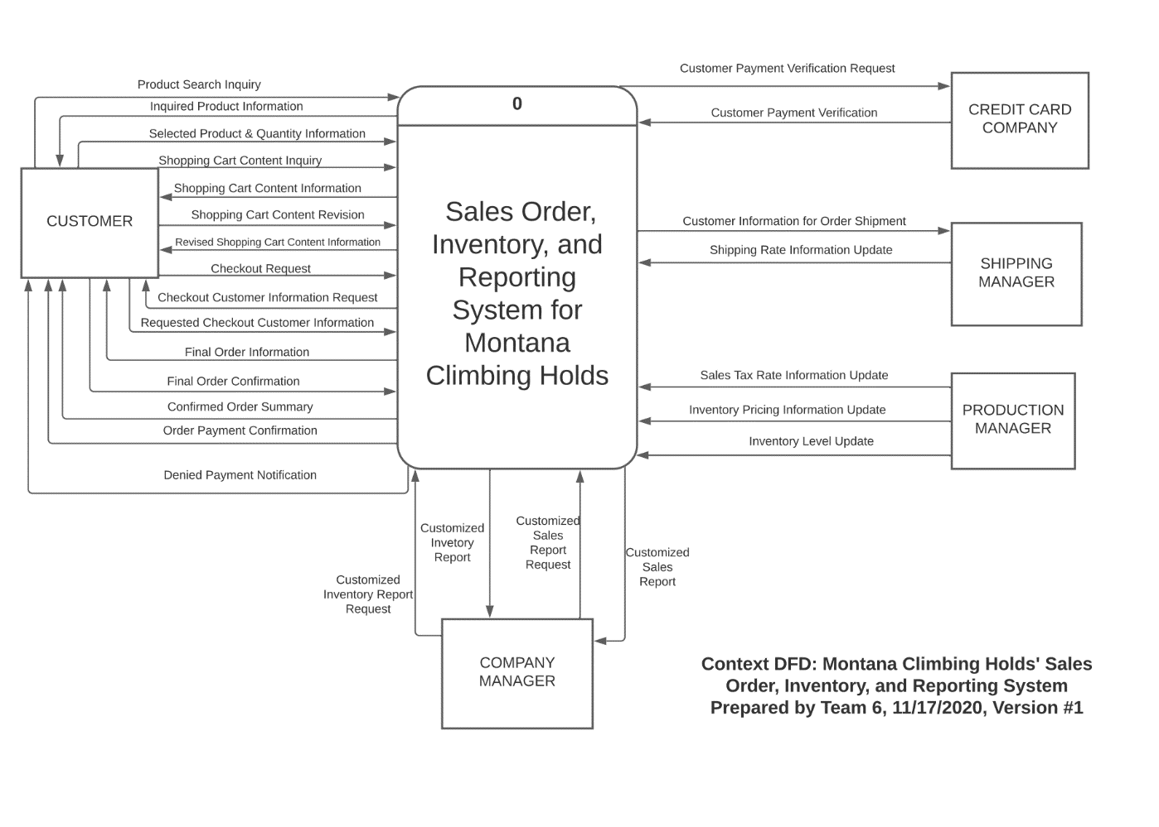

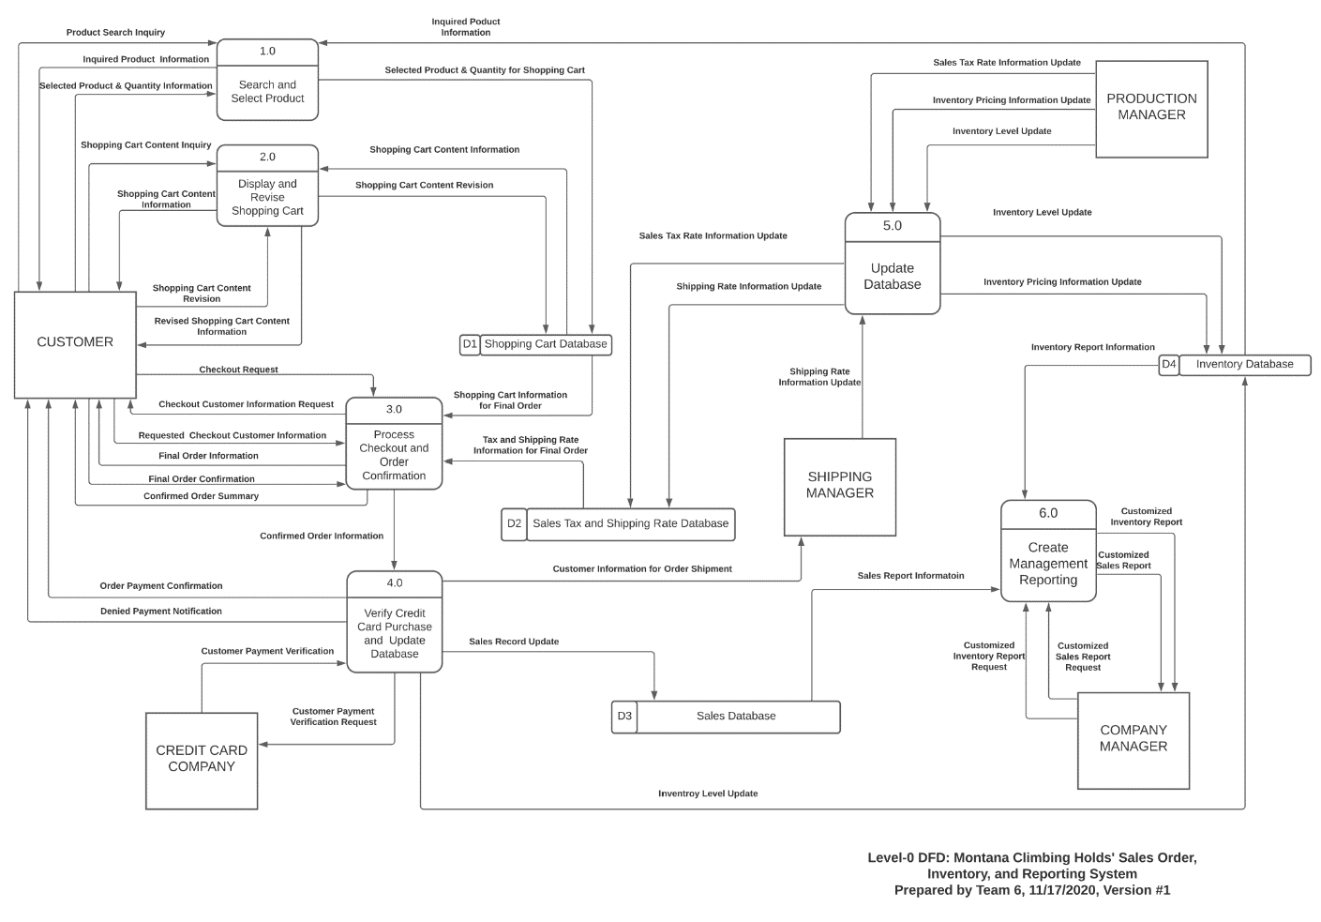

# Data Specification:

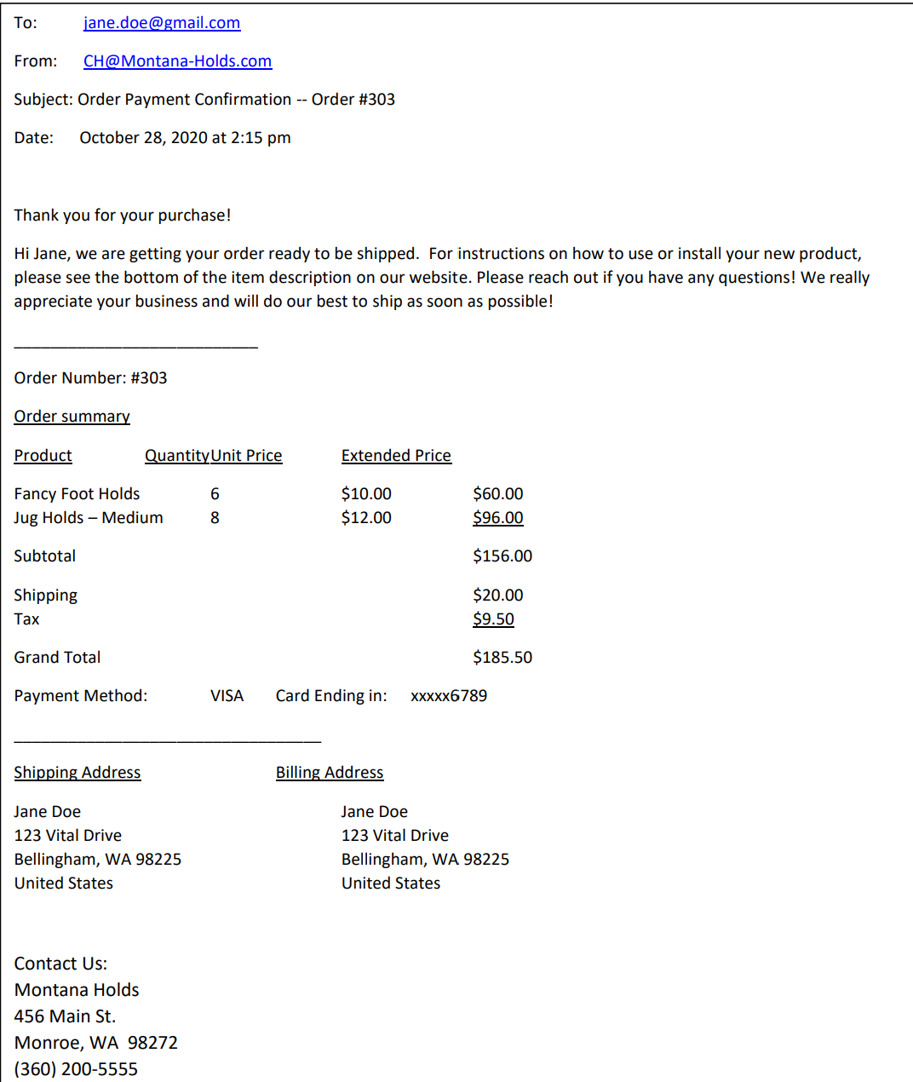

Order Payment Confirmation = Order Number + 1{Product + Quantity + Unit Price + Extended Price} + Subtotal + Shipping + Tax + Grand Total + Payment Method + Card Digits + Customer Shipping Address + Customer Billing Address + Vendor Contact Information

Customer Shipping Address = Customer Name + Street Address + City + State + ZIP Code + Country

Customer Billing Address = Customer Name + Street Address + City + State + ZIP Code + Country

Vendor Contact Information = Vendor Name + Street Address + City + State + ZIP Code + Phone Number

# E-Commerce Assessment:

1. Weebly - weebly.com
   1. Weebly is an online ecommerce software that allows business owners to conduct their business online using the SaaS method. Weebly offers several features such as inventory tracking, online order management, and marketing.
      1. Functionality: 4. Weebly satisfies all software requirements listed.
      2. Reliability: 5. Since Weebly is a very well-known software, it is supported 24/7 and has high ratings for being reliable.
      3. Cost: 5. Weebly’s services start at $26/month which is a relatively lost cost compared to other products being offered.
      4. Ease of Use: 5. Weebly’s website provides step by step instructions for creating domains and provides users with a database of forums to help answer questions.
      5. Level of vendor support: 4. As mentioned in the “Ease of Use” section, Weebly has a forum to help answer questions, they also offer support via phone, email, and priority support.
      6. Flexibility: 4. Weebly offers many different monthly programs to get small businesses started, allowing the customer to upgrade memberships as they see fit.

1. Shopify - [Shopify.com](https://www.shopify.com/free-trial?&term=shopify&Network=Search&SiteTarget=&mt=e&adid=268900212216&device=c&test=&adpos=&CampaignId=788843419&gclid=Cj0KCQiAhs79BRD0ARIsAC6XpaU9SW4OpJIZ6b9oXcn53TLD1NddriKmi512JtKQSTlRwpEOpiPmk-saAoNpEALw_wcB)
   1. Shopify gives the user the ability to scale their operations that allow the business owner to become international, incorporate drop-shipping, and create customer-driven programs (kickbacks, loyalty, points, etc.).
      1. Functionality: 5. Shopify has a large portfolio of items to offer business owners that allows the owner to take control of what they wish to do.
      2. Reliability: 5. Shopify offers 24/7 support teams to always keep your business online.
      3. Cost: 1. Compared to Weebly and Squarespace, Shopify has a much higher price tag.
      4. Ease of Use: 4. Like other online ecommerce websites, Shopify provides guides on how to get started and keeps things simple.
      5. Level of vendor support: 4. aside from the company provided online support, Shopify has a community of independent developers that are available to answers questions.
      6. Flexibility: 5. Shopify provides the user with the ability to have added-on features that can expand the reach of their business.
2. Squarespace: <https://www.squarespace.com/>
   1. Squarespace is an ecommerce website hosting service which hosts a website built by you (Or a designer/ premade template) where you can set up a system to sell your products.
      1. Functionality: 2. Squarespace meets the selling requirement and can manage inventory (Very limited) but is very simple to use and easy to set up.
      2. Reliability: 5. The service is very reliable and is used by millions of users without interruption.
      3. Cost: 3. The cost is relatively low as soon as you start making probably around 10-20 orders per month but can be costly up front (As with other services)
      4. Ease of Use: 5. Squarespace is extremely user friendly and can be designed by yourself or with the help of a certified designer. The layout is also very simple for the customer to navigate if built correctly.
      5. Level of vendor support: 4. Squarespace support is very active and has been very good to me but may be lacking at times due to being such a large service.
      6. Flexibility: 5. A Squarespace website can be used for all kinds of purposes outside of just selling products. There can be a contact page, Sales page, Blog posts, etc. all on the same website easily added to any existing pages.

Our recommendation would be Weebly because it meets all the requested functions, is relatively simple to use for both the management and the customer and has the best cost between the three examples given. Being able to keep track of inventory on the website, run deals, and have automatic tax/shipping calculations are very important to an online business where the customer experience needs to be quick and smooth to ensure sales are made. In addition to the already mentioned benefits, Weebly allows for customization of your websites SEO which is the search engine optimization which means how likely your website will show up on web searches and how likely customers are to click on your websites link versus others.